Response to Ofgem Consultation: Long-Duration Electricity Storage Cap and Floor Framework
Submission Date: 6 July 2026
Respondent: Andy Moran, (Heaviside Analytics — Independent Researcher)
Consultation Reference: Long duration electricity storage window 1: minded-to decisions

1. Introduction
We welcome Ofgem’s consultation on the cap and floor framework for Long‑Duration Electricity Storage (LDES). The regime is a critical step toward mobilising capital for flexible, low‑carbon storage infrastructure. As part of this response, we built a project‑level financial model for all 16 assets in the Window 1 minded‑to portfolio.
This submission is most relevant to Ofgem’s questions on assessment approach, portfolio calibration, and future application windows. Our aim is not to propose a floor price. It is to test how a calibration method built on common parameters performs when set against the physical and geographic realities of the Window 1 pipeline.
By modelling lifecycle costs, duration‑constrained wholesale dispatch, and local transmission‑constraint exposure, we identify three structural sensitivities that merit explicit consideration. LDES provides system‑wide benefits—such as inertia, voltage support, and transmission deferral—that extend beyond wholesale arbitrage and Capacity Market revenues. Even when isolating the pure energy/capacity funding gap, the difference in modelled support between constrained and unconstrained assets is substantial. Duration, constraint exposure and technology‑specific lifecycle costs should therefore be explicit calibration variables within the cap and floor framework.

2. Executive Summary

Lead Finding — Duration Drives Support Requirements

Within the Li‑ion projects in Window 1, duration is the strongest driver of modelled residual support. Under our assumptions, each additional hour adds £27.8k/MW/yr to the equivalent annual support requirement.

PSH, CAES and VFB/Zn follow different cost curves, so they are excluded from the Li‑ion regression. This reinforces the need for technology‑specific modelling, even when duration is treated as a continuous variable. Duration should therefore be an explicit calibration factor within each technology class. The coefficient used here—£27.8k/MW/yr per hour—comes from our assumed cost curves and should be validated against project submissions. It is not a proposed regulatory value.

Supporting Finding — Location Matters

Li‑ion projects behind the SSEN‑S constraint interface require roughly 30% more modelled support than unconstrained projects, after controlling for duration. This should be treated as an upper‑bound estimate, because partial Balancing Mechanism redispatch revenue may offset constraint exposure.

Supporting Finding — PSH Requires Less Floor Support

Under our central assumptions, PSH shows zero modelled residual top‑up. This does not imply PSH can operate without a cap and floor regime. It simply indicates that PSH is less reliant on floor payments than Li‑ion within our simplified revenue stack. This result holds under IDC stress tests: even with an 8% WACC over eight years—equivalent to a 1.36× capex uplift—all three PSH projects still show zero residual top‑up.

Policy Recommendation
Calibration should not rely on common parameters alone. Duration, location and technology‑specific lifecycle costs materially affect support requirements. Duration should anchor calibration within each technology class, with adjustments for constraint exposure and lifecycle cost. Duration coefficients should come from project submissions, not model‑derived estimates.

3. Methodology Overview

3.1 Data Sources
Project technical inputs are taken from the published Window 1 minded‑to portfolio. Cost curves, lifecycle multipliers, curtailment assumptions, WACC and revenue‑stack assumptions are independent modelling assumptions applied transparently for sensitivity analysis. Open‑source price data is sourced from Elexon BMRS for 2021–2024.
The “modelled equivalent annual residual support requirement” is an annualised support‑gap metric expressed in £k/MW/yr. It is not intended to replicate Ofgem’s formal floor calculation; it is used to compare how support need varies across duration, technology and constraint exposure.

3.2 Analytical Approach
The model comprises six sequential stages:
- Geographic Alignment (NB19): Mapped 16 Window 1 projects to transmission constraint zones, identifying seven projects, totalling 5,100 MW, behind the SSEN-S interface.
- Lifecycle Economics (NB20): Calculated technology-specific capex, including mid-life augmentation for Li-ion assets and refurbishment assumptions for PSH, CAES and VFB/Zn.
- Market Revenue Dispatch (NB21): Simulated duration-constrained wholesale arbitrage, where short-duration assets below 24h are limited to daily search windows and long-duration assets of 24h or above are permitted multi-day optimisation.
- Curtailment and RRT Penalty (NB22): Applied a duration-dependent curtailment model in which duration resilience mitigates curtailment loss proportionally. The formula is set out in Section 4.2.
- Stacked Revenue and Required Support (NB23): Combined wholesale arbitrage, Capacity Market revenue and modelled Balancing Mechanism revenue, while treating constraint-period redispatch revenue as zero in the RRT penalty calculation.
- Technology Risk Adjustment (NB24): Applied technology-specific risk adjustments for WACC variance, capex contingency, revenue capture uncertainty and availability risk.

3.3 Key Assumptions
- Li-ion augmentation: 1.70x lifecycle cost multiplier, reflecting an industry-consistent 25-year augmentation schedule.
- PSH energy capacity cost: £20,000/MWh, directionally consistent with the order of magnitude implied by international PSH benchmarks, though direct comparison is sensitive to FX, project scope, financing treatment and site-specific geology.
- Curtailment model: Duration-dependent resilience mitigates curtailment loss; see Section 4.2.
- Capacity Market revenue: £40k–£80k/MW/yr depending on duration.
- WACC: 8%, risk-adjusted.
- Li-ion capex assumptions: Based on current commodity pricing.
Note: Global battery supply chains face significant uncertainty from evolving industrial policy, trade restrictions, and technology transitions. Developers' project-submitted costs should reflect their own supply chain risk assessments, and Ofgem should ensure floor calibration uses conservative cost assumptions that account for this volatility.
Full methodology, assumptions and code are available upon request.

4. Detailed Findings

4.1 Duration Coefficient
Modelled support increases linearly with duration across the 8–18h Li‑ion range. Regression results show a duration coefficient of £27.8k/MW/yr per hour, with an R² of 0.999. The negative intercept has no physical interpretation. Duration should be treated as a continuous calibration variable within technology classes.
Duration Range | Average Modelled Equivalent Annual Residual Support | Interpretation
8h | £169k/MW/yr | Daily arbitrage only
11h | £261k/MW/yr | Enhanced daily flexibility
12h | £278k/MW/yr | Multi-hour shifting
16h | £395k–£524k/MW/yr | Multi-day optimisation; unconstrained: £395k, constrained behind SSEN-S: £524k
18h | £582k/MW/yr | Extended multi-day optimisation
Regression results:
Variable | Coefficient
Intercept | -£51k/MW/yr
Duration | £27.8k/MW/yr per hour
RRT exposure | £127k/MW/yr
Model R² | 0.999

Figure 1 plots Li-ion project duration against modelled equivalent annual residual support requirement. The visual separation between the non-RRT and RRT-exposed model lines shows why duration should be treated as a continuous calibration variable within technology classes, rather than only as a technology-level attribute.
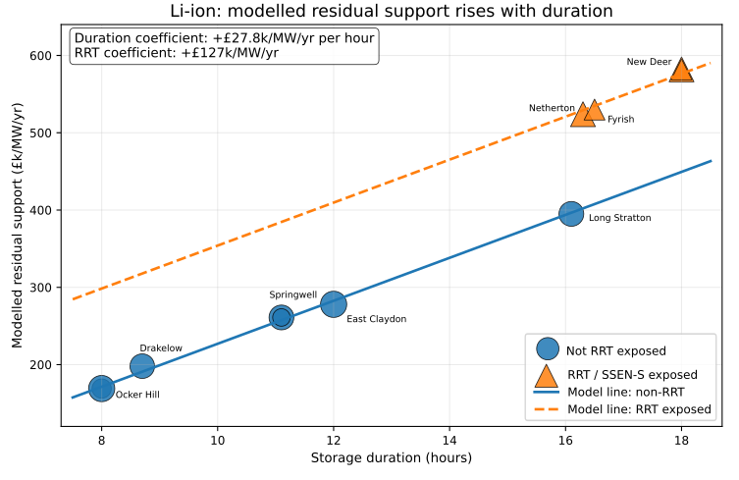
Figure 1 — Duration coefficient within Li-ion. Modelled equivalent annual residual support requirement for the 11 Li-ion Window 1 projects. Marker size scales with MW capacity. The fitted relationship implies approximately £27.8k/MW/yr per additional hour of duration within the modelled 8–18h Li-ion range, with a separate upward shift for RRT/SSEN-S-exposed projects.
Within our parameterisation, each additional hour of duration adds £27.8k/MW/yr to the modelled equivalent annual residual support requirement. This continuous relationship provides evidence that duration should be an explicit calibration variable within technology classes.

4.2 Geographic Premium
Li‑ion projects behind SSEN‑S require 29–30% more modelled support than duration‑controlled baselines. The model structure links curtailment exposure to duration resilience. Balancing Mechanism redispatch may reduce the true premium, so the estimate should be treated as an upper bound.

Project | Duration | Location | Modelled Equivalent Annual Residual Support | Premium vs Baseline
Field Netherton | 16.3h | North Scotland (RRT) | £524k/MW/yr | +30.1%
Field Fyrish | 16.5h | North Scotland (RRT) | £530k/MW/yr | +29.9%
Field New Deer | 18.0h | North Scotland (RRT) | £582k/MW/yr | +29.3%
Field Rigifa | 18.0h | North Scotland (RRT) | £582k/MW/yr | +29.3%
Figure 2 compares each RRT-exposed Li-ion project with the duration-controlled non-RRT baseline implied by the Li-ion duration coefficient. The result is a consistent uplift of approximately 29–30%, illustrating the materiality of geographic constraint exposure.
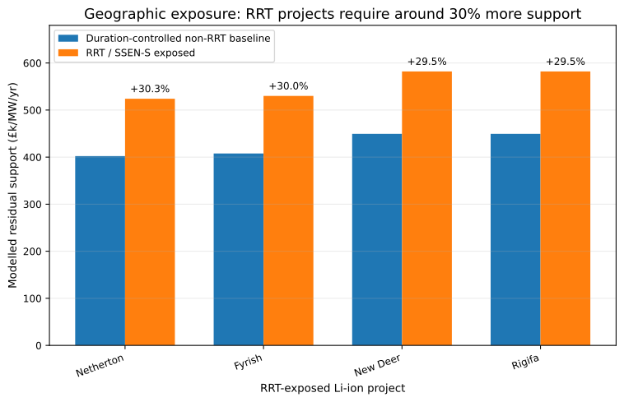
Figure 2 — Geographic premium for RRT-exposed Li-ion projects. Duration-controlled comparison between the non-RRT baseline implied by the Li-ion duration coefficient and the modelled support requirement for RRT/SSEN-S-exposed projects. The exposed projects sit approximately 29–30% above the duration-controlled non-RRT baseline.

Model structure:
duration_resilience = min(1.0, duration_hours / 24.0)
curtailment_loss_factor = rrt_persistence_score × (1 - duration_resilience)
delivered_fraction = 1 - curtailment_loss_factor
LCOS adjustment = total_annual_cost / adjusted_mwh_delivered
The rrt_persistence_score of 0.82 represents the proportion of hours when constraints are active. A zero-duration asset would face 82% curtailment loss. Longer-duration assets mitigate this loss proportionally through their ability to time-shift discharge to unconstrained hours. For example, Coire Glas, with 32h duration and 100% resilience, faces 0% loss; Loch Kemp, with 22h duration and 93% resilience, faces 6% loss; and Earba, with 15h duration and 63% resilience, faces 31% loss.
Important caveat — Balancing Mechanism redispatch:
The model assumes full curtailment exposure during constraint-active hours for SSEN-S. The magnitude may be overstated if partial Balancing Mechanism redispatch revenue is available during constraint events, in which case the true geographic premium would be lower than 30%. The current model treats BM redispatch revenue as zero during constraint periods, which represents an upper-bound estimate of the geographic effect.

4.3 PSH Support Requirement
PSH projects show robust near‑zero modelled residual support under central assumptions and under IDC stress tests. Key drivers include low energy‑capacity cost, long duration, and a low lifecycle multiplier. External benchmarks (e.g., Snowy 2.0) support the plausibility of the assumed cost range.
Project | Duration | Curtailment Loss | Modelled Equivalent Annual Residual Support
Coire Glas | 32h | 0% (100% resilience) | £0k/MW/yr
Loch Kemp Storage | 22h | 6% (93% resilience) | £0k/MW/yr
Earba | 15h | 31% (63% resilience) | £0k/MW/yr

Figure 3 places the PSH, CAES, VFB/Zn and Li-ion projects on the same duration/support axes. The chart shows that PSH does not sit on the Li-ion support curve: it occupies a distinct region with long duration and zero modelled residual top-up under central assumptions.
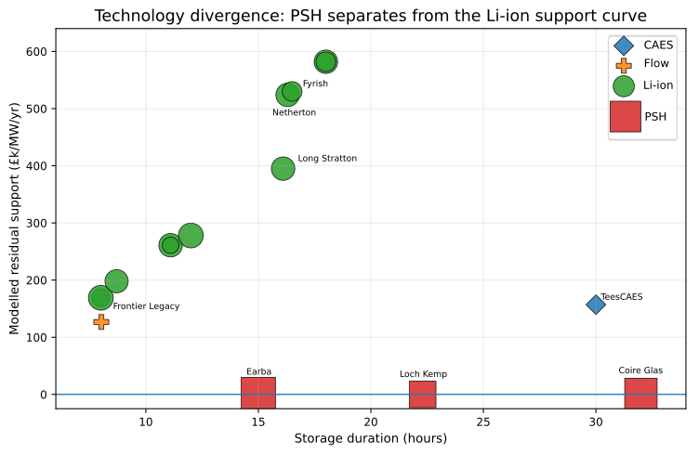

Figure 3 — Technology divergence. Project-level duration versus modelled equivalent annual residual support across the Window 1 portfolio. PSH projects occupy a distinct region of the chart: long duration and zero modelled residual top-up under central assumptions, while Li-ion projects follow a steep duration-linked support curve.
Key drivers:
- Low energy capacity cost: £20,000/MWh, compared with £250,000/MWh for Li-ion in this model.
- Long duration: 15–32h enables high Capacity Market revenue and curtailment mitigation.
- Low lifecycle multiplier: 1.15x, compared with 1.70x for Li-ion.
IDC stress test:
PSH projects require 7–10 years of construction before generating revenue. We stress-tested the zero-floor finding by applying an IDC factor of 1.36x, representing an 8% WACC over eight years of construction under a midpoint approximation. All three PSH projects maintained zero modelled residual top-up under this stress test, confirming that the finding is robust to construction-period financing risk under the modelled assumptions.

External validation:
Snowy 2.0 provides a useful external benchmark for the order of magnitude of PSH energy-capacity cost, though direct comparison is sensitive to FX, scope, financing treatment and project-specific geology. Our £20k/MWh assumption is directionally plausible. The finding is robust across the £15k–£30k/MWh sensitivity range and IDC stress test.

4.4 Cost-Revenue Gap
Support requirements reflect the gap between levelised cost of storage (LCOS) and market revenues. PSH’s low LCOS (£30–58/MWh) results in zero modelled support, while Li‑ion’s higher LCOS (£131–180/MWh) creates substantial support requirements (£169k–582k/MW/yr).
Figure 4 visualises the relationship between levelised cost of storage (LCOS) and modelled residual support requirement across all 16 projects. The chart demonstrates that support requirements are not arbitrary — they are driven by the fundamental economic gap between project costs and market revenues.

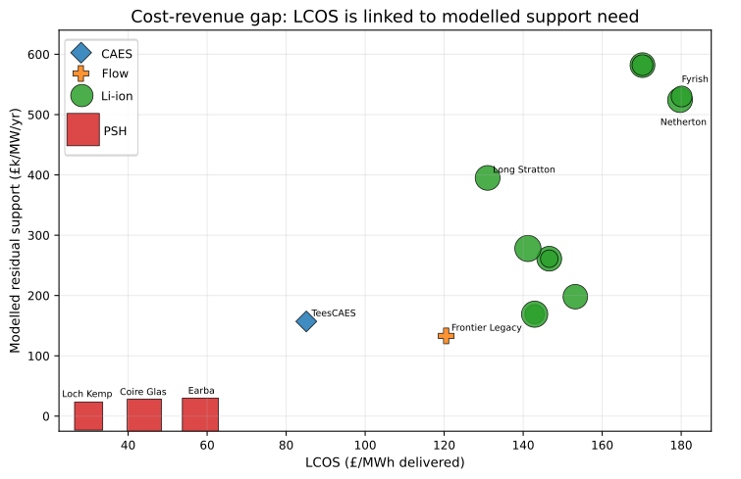
Figure 4 — Cost-revenue gap drives support requirements. Levelised Cost of Storage (LCOS) vs modelled residual support requirement. Projects with higher LCOS require greater residual support, with distinct clustering by technology. PSH's low cost structure (£30-58/MWh) results in zero modelled residual support, while Li-ion's higher costs (£131-180/MWh) create substantial support requirements (£169k-582k/MW/yr). The floor mechanism fills the gap between project costs and market revenues.

5. Policy Implications

5.1 Limits of Common Parameters
A calibration method built on common parameters risks:
- over-supporting resilient long-duration assets, creating unnecessary consumer cost;
- under-supporting constrained shorter-duration assets, particularly Li-ion projects behind SSEN-S; and
- distorting the optimal technology mix by failing to account for duration and location.

5.2 Recommended Calibration Framework
Calibration should follow three dimensions:
- Duration
coefficients should come from project submissions.
- Geographic constraint exposure
the ~30% premium is an upper‑bound estimate.
- Technology-specific lifecycle costs
augmentation/refurbishment profiles differ materially.
This approach would support technology lifecycle costs, physical duration and geographic constraint exposure, reduce the risk of unintended capital misallocation and enable project delivery.

5.3 Implementation Considerations
PSH’s zero‑floor result is robust under modelled assumptions but does not guarantee investment viability. Duration coefficients should be empirically validated, and geographic premiums refined using BM redispatch data.

6. Conclusion
Cap and floor calibration cannot rely solely on common parameters. Duration, constraint exposure and lifecycle cost drive substantial differences in modelled support requirements—even within the same technology class. A calibration framework that recognises these variables will reduce misallocation risk and support effective delivery across the Window 1 portfolio.
We welcome further discussion and can provide additional analysis as required.

Footnotes
¹ IDC factor computed using midpoint approximation: (1.08)⁴ = 1.36x. The exact IDC factor varies by drawdown convention; 1.36x is used here as a transparent midpoint approximation.

Annexes

Annex A: Data Traceability and Methodology

A.1 Source Data
Project technical inputs are derived from the published Window 1 minded-to portfolio. Cost curves, lifecycle multipliers, curtailment assumptions, WACC and revenue-stack assumptions are independent modelling assumptions applied transparently for sensitivity analysis. Open-source price data is sourced from Elexon BMRS for 2021–2024. The complete analytical pipeline is available for audit.

A.2 Headline Figure 1: Duration Coefficient (£27.8k/MW/yr per hour)
Source file: ldes_portfolio_risk_adjusted.parquet
Relevant columns: residual_floor_adjusted, duration_hours, rrt_applicable, economic_archetype
Scenario: Risk-adjusted
Calculation: Multiple regression of modelled equivalent annual residual support on duration and RRT exposure for all 11 Li-ion projects.
Variable | Coefficient
Intercept | -£51k/MW/yr
Duration | £27.8k/MW/yr per hour
RRT exposure | £127k/MW/yr
Model R² | 0.999
Interpretation: Within our parameterisation, each additional hour of duration adds £27.8k/MW/yr to the modelled equivalent annual residual support requirement. This relationship provides evidence that duration should be an explicit calibration variable within technology classes. The coefficient is not proposed as an empirical regulatory value.

A.3 Headline Figure 2: Geographic Premium (~30%)
Source file: ldes_portfolio_risk_adjusted.parquet
Relevant columns: residual_floor_adjusted, duration_hours, rrt_applicable
Scenario: Risk-adjusted
Duration-controlled premiums:
Project | Duration | Premium
Field Netherton | 16.3h | +30.1%
Field Fyrish | 16.5h | +29.9%
Field New Deer | 18.0h | +29.3%
Field Rigifa | 18.0h | +29.3%

Model structure:
duration_resilience = min(1.0, duration_hours / 24.0)
curtailment_loss_factor = rrt_persistence_score × (1 - duration_resilience)
delivered_fraction = 1 - curtailment_loss_factor
LCOS adjustment = total_annual_cost / adjusted_mwh_delivered
Important caveat — Balancing Mechanism redispatch:
The model assumes full curtailment exposure during constraint-active hours for SSEN-S. The magnitude may be overstated if partial Balancing Mechanism redispatch revenue is available during constraint events, in which case the true geographic premium would be lower than 30%.

A.4 PSH Support Requirement
PSH projects demonstrate robust near-zero modelled equivalent annual residual support requirements, including under IDC stress testing. This should not be interpreted as evidence that PSH does not require a cap and floor regime; rather, it indicates that PSH appears materially less reliant on floor-related payments than Li-ion within our simplified energy/capacity revenue stack.
IDC stress test:
WACC | Construction Years | IDC Factor | PSH Modelled Residual
8% | 8 | 1.36x | £0k/MW/yr
All three PSH projects maintained £0k modelled residual top-up under this stress test. The finding is robust to construction-period financing risk under the modelled assumptions.
External validation:
Snowy 2.0 provides a useful external benchmark for the order of magnitude of PSH energy-capacity cost, though direct comparison is sensitive to FX, scope, financing treatment and project-specific geology. The £20k/MWh assumption is directionally plausible.

A.5 Li-ion Lifecycle Multiplier
Source file: ldes_portfolio_economics.parquet
Relevant columns: initial_capex_gbp, lifecycle_capex_gbp
Our model applies an industry-consistent 25-year augmentation schedule to Li-ion technology, yielding a 1.70x lifecycle cost multiplier. This reflects the cumulative cost of mid-life battery replacement over the 40-year project lifecycle.

Annex B: Sensitivity Analysis

B.1 PSH Capex Sensitivity
capex_mwh | Coire Glas Modelled Residual | Earba Modelled Residual | Loch Kemp Modelled Residual | Status
£15k/MWh | £0k | £0k | £0k | Materially less reliant
£20k/MWh | £0k | £0k | £0k | Materially less reliant
£25k/MWh | £0k | £0k | £0k | Materially less reliant
£30k/MWh | £0k | £0k | £0k | Materially less reliant

B.2 IDC Sensitivity
WACC | Construction Years | IDC Factor | PSH Modelled Residual
6% | 8 | 1.27x | £0k
8% | 8 | 1.36x | £0k
10% | 8 | 1.47x | £0k
8% | 10 | 1.47x | £0k

B.3 RRT Persistence Sensitivity
Persistence Score | Geographic Premium
0.70 | ~20%
0.82 baseline | ~30%
0.90 | ~40%

Annex C: Full Project-Level Results
To preserve readability in the consultation response, the full project-level results are split into three linked tables: technical inputs, modelled cost/revenue outputs, and the headline modelled residual support result. The underlying project identifiers are consistent across all three tables.
Model inputs are derived from the Window 1 minded-to portfolio and rounded where used in the analytical pipeline. The economic outputs are model-derived and should be interpreted as scenario results rather than Ofgem floor determinations.

C.1 Portfolio Technical Inputs
Project | Technology | Region | MW | MWh | Duration | RRT
TeesCAES | CAES | North East England | 50 | 1,500 | 30.0h | No
Frontier Legacy | VFB/Zn | North Wales | 65 | 520 | 8.0h | No
Ocker Hill BESS | Li-ion | West Midlands | 145 | 1,160 | 8.0h | No
Sundon Storage | Li-ion | East England | 500 | 4,000 | 8.0h | No
Drakelow (Innova) | Li-ion | West Midlands | 385 | 3,350 | 8.7h | No
Springwell | Li-ion | East Midlands | 400 | 4,440 | 11.1h | No
Thornton BESS 2 | Li-ion | East Midlands | 100 | 1,110 | 11.1h | No
East Claydon Storage | Li-ion | East England | 500 | 6,000 | 12.0h | No
Field Long Stratton | Li-ion | East England | 400 | 6,440 | 16.1h | No
Field Netherton | Li-ion | North Scotland | 400 | 6,520 | 16.3h | Yes
Field Fyrish | Li-ion | North Scotland | 200 | 3,300 | 16.5h | Yes
Field New Deer | Li-ion | North Scotland | 400 | 7,200 | 18.0h | Yes
Field Rigifa | Li-ion | North Scotland | 200 | 3,600 | 18.0h | Yes
Earba | PSH | North Scotland | 1,800 | 27,000 | 15.0h | Yes
Loch Kemp Storage | PSH | North Scotland | 660 | 14,718 | 22.3h | Yes
Coire Glas | PSH | North Scotland | 1,440 | 46,080 | 32.0h | Yes

C.2 Modelled Cost and Revenue Outputs
Project | Initial Capex £bn | Lifecycle Capex £bn | LCOS £/MWh | Annual MWh Delivered | Gross Revenue £m/yr | CM £k/MW/yr
TeesCAES | 0.150 | 0.165 | 85.1 | 173,217 | 8.45 | 80
Frontier Legacy | 0.123 | 0.166 | 120.5 | 142,350 | 11.02 | 40
Ocker Hill BESS | 0.341 | 0.579 | 142.9 | 370,475 | 29.47 | 40
Sundon Storage | 1.175 | 1.998 | 142.9 | 1,277,500 | 101.61 | 40
Drakelow (Innova) | 0.972 | 1.653 | 153.2 | 983,675 | 78.24 | 42
Springwell | 1.250 | 2.125 | 146.6 | 1,314,000 | 96.73 | 48
Thornton BESS 2 | 0.312 | 0.531 | 146.6 | 328,500 | 24.18 | 48
East Claydon Storage | 1.675 | 2.848 | 141.2 | 1,825,000 | 131.35 | 50
Field Long Stratton | 1.750 | 2.975 | 131.0 | 2,044,000 | 127.71 | 60
Field Netherton | 1.770 | 3.009 | 179.7 | 1,506,258 | 75.19 | 61
Field Fyrish | 0.895 | 1.522 | 180.1 | 760,112 | 37.94 | 61
Field New Deer | 1.940 | 3.298 | 170.2 | 1,741,050 | 80.41 | 65
Field Rigifa | 0.970 | 1.649 | 170.2 | 870,525 | 40.21 | 65
Earba | 2.700 | 3.105 | 58.3 | 5,004,698 | 236.62 | 58
Loch Kemp Storage | 1.086 | 1.249 | 30.0 | 3,857,431 | 155.23 | 76
Coire Glas | 2.650 | 3.047 | 44.1 | 6,301,440 | 331.15 | 80

C.3 Headline Modelled Support Result
Project | Technology | Duration | RRT | Modelled Equivalent Annual Residual Support
TeesCAES | CAES | 30.0h | No | £157k/MW/yr
Frontier Legacy | VFB/Zn | 8.0h | No | £133k/MW/yr
Ocker Hill BESS | Li-ion | 8.0h | No | £169k/MW/yr
Sundon Storage | Li-ion | 8.0h | No | £169k/MW/yr
Drakelow (Innova) | Li-ion | 8.7h | No | £198k/MW/yr
Springwell | Li-ion | 11.1h | No | £261k/MW/yr
Thornton BESS 2 | Li-ion | 11.1h | No | £261k/MW/yr
East Claydon Storage | Li-ion | 12.0h | No | £278k/MW/yr
Field Long Stratton | Li-ion | 16.1h | No | £395k/MW/yr
Field Netherton | Li-ion | 16.3h | Yes | £524k/MW/yr
Field Fyrish | Li-ion | 16.5h | Yes | £530k/MW/yr
Field New Deer | Li-ion | 18.0h | Yes | £582k/MW/yr
Field Rigifa | Li-ion | 18.0h | Yes | £582k/MW/yr
Earba | PSH | 15.0h | Yes | £0k/MW/yr
Loch Kemp Storage | PSH | 22.3h | Yes | £0k/MW/yr
Coire Glas | PSH | 32.0h | Yes | £0k/MW/yr
Full data are traceable to the Window 1 minded-to portfolio inputs and analytical pipeline at:
Data pipeline: https://github.com/AndyMoran/ldes-window1-modelling.
Contact:
Email Contact: andregmoran@gmail.com
Linkedin: https://www.linkedin.com/in/andy-graham-moran/
Github: https://github.com/AndyMoran/ldes-window1-modelling

End of Submission

